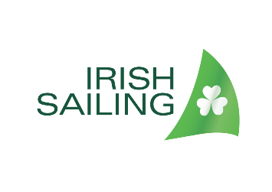
Background bios for Irish Sailing Team
Media Briefing, Tuesday 20 October 2020

The Irish Sailing team is made up of sailors from Dublin, Cork, and Carlow, three experienced Olympic sailors, 2 x 49er teams, and one pair of siblings.
__________________________________________________________________________________

49er skiff – Men’s double-hander
Ryan Seaton & Seafra Guilfoyle
Robert Dickson & Sean Waddilove

Laser Standard – single-hander
Liam Glynn
Finn Lynch
Ewan McMahon

Laser Radial – single-hander
Annalise Murphy
Aoife Hopkins
Eve McMahon

_______________________________________________________________________________
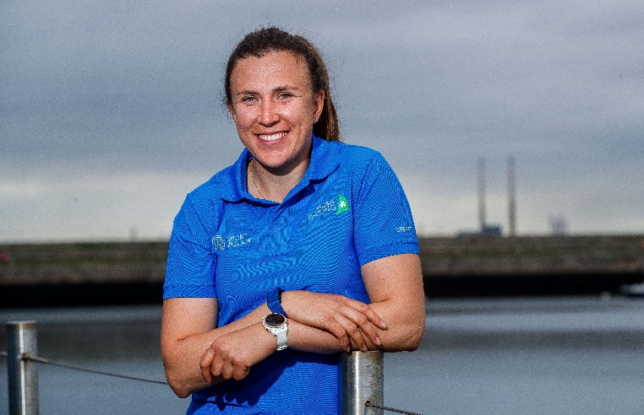
ANNALISE MURPHY, Laser Radial
Age 30. From Rathfarnham, Dublin.
Club: National Yacht Club
Full-time sailor
Silver medallist at the 2016 Olympic Games, Rio (Laser Radial class). Competed in the Volvo Ocean Race 2017/2018. Represented Ireland at the London 2012 Olympics. Laser Radial European Champion in 2013.
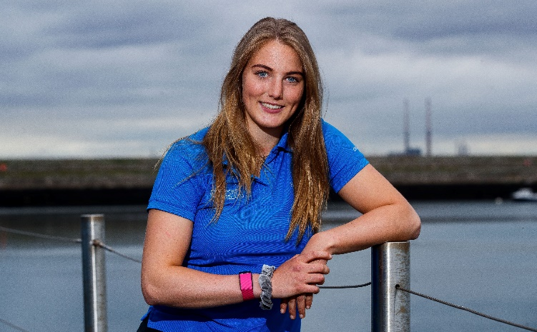
AOIFE HOPKINS, Laser Radial
European Champion for U21 Laser Radial in 2017.
DOB: 30 October 1991. From Howth, Dublin.
Club: Howth Yacht Club
Currently studying Maths at UCD
When and where did you first try sailing? | In Howth Yacht Club back when I was nine years old doing Start Sailing
Who introduced you to sailing? | My dad, he basically pushed me out in an oppie (Optimist) and away I went!
Do you remember the first race you won? | No actually, all a bit of a distant memory, maybe regatta fleet in the optimist?
When did you first represent Ireland? | Optimist Under 12 squad at the British Nationals in 2009
Who has been the biggest influence on your sailing career to date? | My parents, who introduced me to the sport and have supported me every step of the way.
Who is your sporting hero ? | Probably Michael Phelps, he's an amazing athlete.

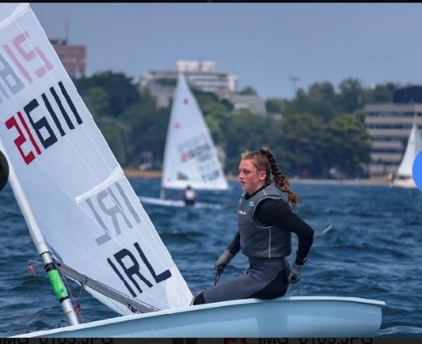
EVE McMAHON, Laser Radial
2019 Under 17 Gold Medallist at the Laser Radial Youth World Championships, and Volvo Youth Sailor of the Year 2019
Age 16. From Howth, Dublin.
Club: Howth Yacht Club
5th Year Secondary School – Institute of Education

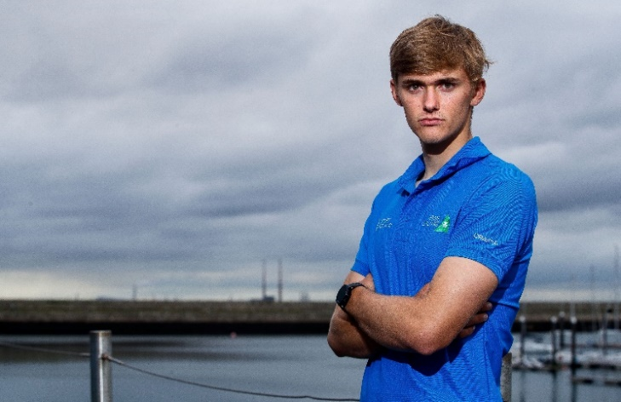
ROBERT DICKSON, 49er (sails with Sean Waddilove).
Winner, U23 49er World Championships, September 2018, and 2018 Volvo Irish Sailor of the Year
DOB: 6 March 1998, from Sutton, Co. Dublin.
Club: Howth Yacht Club
Currently studying: Sports Science and Health in DCU with a Sports Scholarship.
When and where did you first try sailing? | When I was 6 in Lough Ree Yacht Club
Who introduced you to sailing? | My Parents
Do you remember the first race you won? | Not the first race but I remember the first regatta I won. It was a small club regatta in Lough Ree in 2007
When did you first represent Ireland? | When I was 11 at the UK Nationals in Largs
Who has been the biggest influence on your sailing career to date? | My Dad probably had the biggest impact since he used to travel around the country with me to all the oppy (Optimist) events and go out in the rib as a support boat

Who is your sporting hero ?

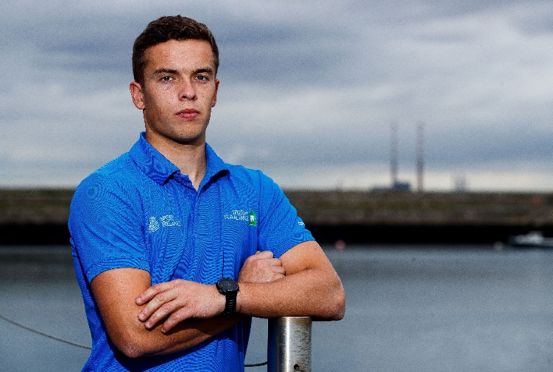
SEAN WADDILOVE, 49er (sails with Robert Dickson)
Winner, U23 49er World Championships, September 2018, and recently awarded 2018 Volvo Irish Sailor of the Year
DOB: 19 June 1997. From Skerries, Dublin
Club: Skerries Sailing Club and Howth Yacht Club
Currently studying International Business and Languages and awarded sports scholarship at TU (Technology University)
When and where did you first try sailing? | When I was 8 years old at a Taste of Sailing Course at my home club, Skerries Sailing Club.
Who introduced you to sailing? | My Dad.
Do you remember the first race you won? | I can't remember exactly when but I would have thought it was club racing in Skerries.
When did you first represent Ireland? | I first represented Ireland on the U12 Squad at the UK Nationals in Largs 2009.
Who has been the biggest influence on your sailing career to date? | My parents.

Who is your sporting hero ?

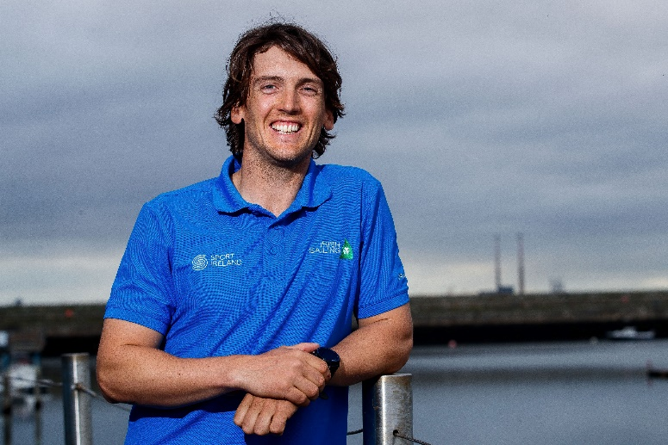
RYAN SEATON, 49er (sails with Seafra Guilfoyle)
Represented Ireland, and medal race finalist at the Olympic Games in London 2012, and Rio 2016 (49er class)
DOB: 3 December 1997. From Carrickfergus, Co. Antrim.
Club: Carrickfergus Sailng Club and Ballyholme Yacht Club
Full-time sailor.
When and where did you first try sailing? | Age 5 but I think I was actually on a boat after few months of being born! Sailing on family boats around Ireland & Scotland.
Who introduced you to sailing? | My Dad.
Do you remember the first race you won? | Optimist Northerns.
When did you first represent Ireland? | 1999 Mirror Worlds in South Africa.
Who has been the biggest influence on your sailing career to date? | My Dad.
Where is the best sailing venue in Ireland / the world ? | Belfast Lough/ Lake Garda, Italy

Who is your sporting hero ?

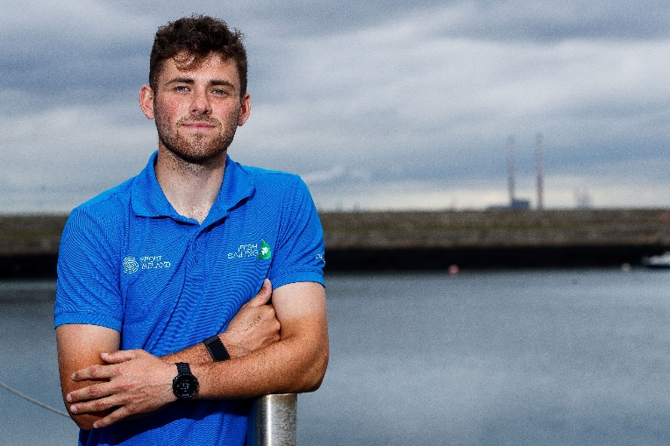
SEAFRA GUILFOYLE, 49er (sails with Ryan Seaton)
Silver medallist at the 2014 Youth World Championships in Laser Radial
DOB: 3 July 1996. From Cork.
Club: Royal Cork Yacht Club
Full-time sailor (deferred his Sports Scholarship from UCC)
When and where did you first try sailing? | When I was 7, in the Royal Cork Yacht Club
Who introduced you to sailing? | My mum and dad
Do you remember the first race you won? | Tuesday night league racing in Optimists
When did you first represent Ireland? | In 2007, the under 12 squad for the British National Championships
Who has been the biggest influence on your sailing career to date? | My parents
Who is your sporting hero ? | Rory McIlroy, Cristiano Ronaldo

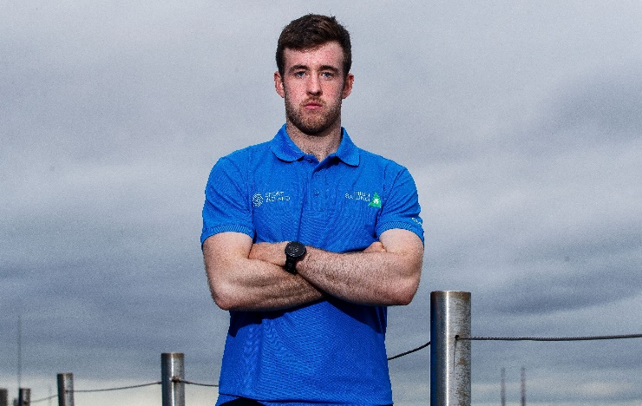
FINN LYNCH, Laser Standard
Ireland’s youngest helm ever to compete at the Olympic Games (Rio 2016). U19 World Champion in the Laser in 2014; and silver medallist in the 2012 Youth World Championships (Laser Radial).
DOB: 23 April 1996. From Carlow.
Club: National Yacht Club
Full-time sailor.
When and where did you first try sailing? | Blessington sailing club when I was 8. My Dad got into the water waist deep holding on to my boat from a rope!
Who introduced you to sailing? | My Dad and my two older brothers.
Do you remember the first race you won? | Bennekerry field day egg and spoon race! But I cheated...
When did you first represent Ireland? | Topper British Nationals 2007
Who has been the biggest influence on your sailing career to date? | Jozo Jakelic
Who is your sporting hero ? | Paul O Connell

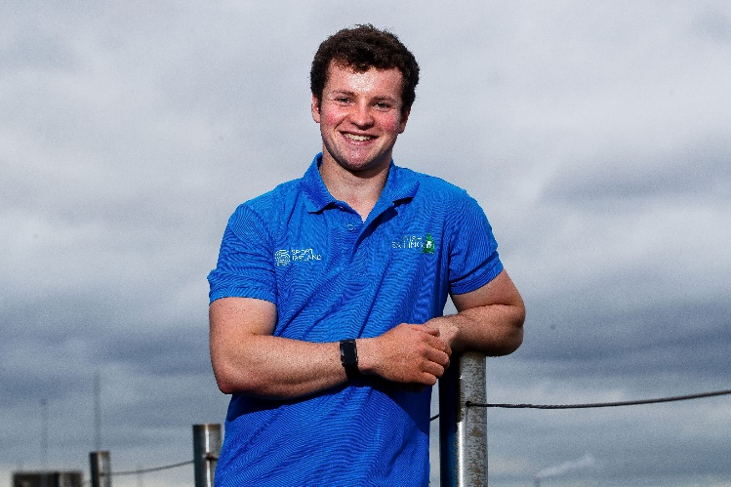
LIAM GLYNN, Laser Standard
Bronze medallist at U21 World Championships in Laser. Topper World Champion in 2013.
DOB: 17 April 1998. From Bangor, Co. Down.
Club: Ballyholme YC
Currently studying Maths and Physics in UCD with Ad Astra Sports Scholarship.
When and where did you first try sailing? | Around the age of 7 at Ballyholme Yacht Club.
Who introduced you to sailing? | Nobody really, we just live nearby to the sailing club and decided to try it as a family
Do you remember the first race you won? | ISA Youth National 2012 in Topper class
When did you first represent Ireland? | At the Topper World in 2011 in Dun Laoghaire
Who has been the biggest influence on your sailing career to date? | At a younger age my brother and other older sailors from my club had a big influence. I always had someone to train with who was above my level and this helped me to get better.
Who is your sporting hero ? | Mohammed Ali

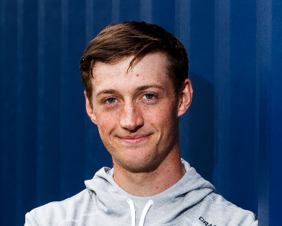
EWAN McMAHON, Laser Standard
Silver medallist at the Laser Radial Youth World Championships, 2016
DOB: 28 June 1999. From Howth, Dublin.
Club: Howth Yacht Club
Currently studying Engineering at UCD and Ad Astra Sports Scholarship
When and where did you first try sailing? | I first experienced a taste for sailing at my local sailing club (HYC) in an introductory sailing course during my primary school summer break when i was about 7/8 years old.
Who introduced you to sailing? | My Dad was the primary person who introduced me to sailing. He enjoyed sailing from when he first started himself as a teenager and thought I might like to try it, especially as we lived near the water.
Do you remember the first race you won? | The first race I remember winning was at the Optimist Crosbie Cup. It was an exciting moment crossing the line in 1st place, especially as it came as a surprise to my parents and because it was one of my first regattas.
When did you first represent Ireland? | I first represented Ireland in the Optimist class as part of the Irish U12 team . The team travelled to Wales to compete at the UK Nationals where many other international teams were also racing.
Who has been the biggest influence on your sailing career to date? | My family have definitely been the biggest influence on my sailing career to date. Success or failure, they are always there to support me no matter what. On top of that, I have two younger siblings (Eve & Jamie) who are also keen sailors, so it makes for a fun family atmosphere when we get to go racing together .
Who is your sporting hero ? | I don't necessarily have one particular sporting hero; I more look up to all the great professional athletes in my sport and in other sports, taking inspiration from how they train and conduct themselves to compete/succeed at the highest levels.

